**PROGRAM 11**

NAME -Lalit singh

COURSE -MCA 1st Sem

ROLL NO -2351027

SUBJECT -Full Stack Development Laboratory (PMC-101)

**OBJECTIVE: To Design the following static web pages required for online bookstore.**

* **Home page: - the static home page must contain three pages**
* **Top frame: - logo and college name and links to homepage, login page, registration Page,**
* **catalogue page and cart page**
* **Left frame: - at least four links for navigation which will display the catalogue of Respective links**
* **Right frame: - the pages to links in the left frame must be loaded here initially it Contains the**
* **description of the website**
* **Registration page and**
* **Cart page**

**HTML CODE:**

1. **INDEX.html**

<!DOCTYPE html>

<html lang="en">

<head>

<frameset rows="20%,*">

<frame src="topframe.html"name="f1">

<frameset cols="10%,*">

<frame src="leftframe.html"name="f2">

<frame src="rightframe.html"name="f3">

</frameset>

</frameset>

</head>

</html>

1. **topframe.html**

<html>

<head>

<link rel="stylesheet" href="style.css">

</head>

<body>

<nav class="topnav">

<img src="gehulogo.jpeg" >

<h1>Online book store</h1>

<ul class="topul" >

<li><a href="index.html" target="_parent">Home</a></li>

<li><a href="login.html" target="f3">login</a></li>

<li><a href="registration.html" target="f3">registration</a></li>

<li> <a href="catalogue.html" target="f3">Catalogue</a></li>

<li><a href="cart.html" target="f3">Cart</a></li>

</ul>

</nav>

</body>

</html>

1. **leftframe.html**

<html>

<head>

<link rel="stylesheet" href="style.css">

</head>

<body>

<nav>

<ul class="leftnav">

<li><a href=bca.html target="f3"><h3>BCA</h3> </a></li>

<li><a href=mca.html target="f3"><h3>MCA</h3></a></li>

<li><a href=bba.html target="f3"><h3>BBA</h3></a></li>

<li><a href=mba.html target="f3"><h3>MBA</h3></a></li>

</ul>

</nav>

</body>

</html>

1. **rightframe.html**

<html>

<head>

<link rel="stylesheet" href="style.css">

</head><body>

<p>

<h1 align="center"> Online book store information </h1>

<p> nvesting in high-quality textbooks is an investment in your future success. By providing you with the right resources, we empower you to acquire the knowledge and skills necessary to excel in your chosen field. Whether you're aiming for a top-tier job or pursuing further education, we believe that access to reliable and relevant information is key to achieving your goals.</p>

</p>

</body>

</html>

1. **login.html**

<html>

<head>

<p style= "background:yellow; top:100px; left:250px; position:absolute; ">

</head>

<body>

<center>

<br><br>

<h1>Login Form</h1>

<form action="#" >

username : <input type="text"><br><br>

password : <input type="password" ><br><br>

<input type="submit">

<input type="reset">

</form>

<br><br></center>

</body>

</html>

1. **registration.html**

<!DOCTYPE html>

<html lang="en">

<body>

<center>

<br><br>

<h1>Registration Form</h1>

<form action="#" >

name: <input type="text"><br><br>

password : <input type="password"><br><br>

age: <input type="number"><br><br>

roll no : <input type="number"><br><br>

gender : <input type="radio" name="r1"> male <input type="radio" name="r1"> female <br><br>

<input type="submit">

<input type="reset" >

</form>

<br><br>

</center>

</body>

</html>

1. **mca.html**

<html>

<body>

<center>

<h1>MCA Course Catalogue</h1>

<table border=1>

<tr>

<th> Book Preview </th>

<th> Book Details </th>

<th> Price </th>

<th> Payment </th>

</tr>

<tr>

<td> <img src="book.jpeg" width=100 height=50>

</img>

</td>

<td>

<span><p> book:XML Bible</p>

<p> Author:winston</p>

<p>Publisher:Wiesley</p></span>

</td>

<td>1500 INR </td>

<td> <a href="cart.html" target="_blank">

<img src="payment.png" width="150" height="100"></img>

</a>

</td>

</tr>

<tr>

<td> <img src="book.jpeg" width=100 height=50>

</img>

</td>

<td>

<span><p> book:XML Bible</p>

<p> Author:winston</p>

<p>Publisher:Wiesley</p></span>

</td>

<td> 1580 INR </td>

<td> <a href="cart.html" target="_blank">

<img src="payment.png" width="150" height="100"></img>

</a>

</td>

</tr>

<tr>

<td> <img src="book.jpeg" width=100 height=50>

</img>

</td>

<td>

<span><p> book:XML Bible</p>

<p> Author:winston</p>

<p>Publisher:Wiesley</p></span>

</td>

<td>1580 INR </td>

<td> <a href="cart.html" target="_blank">

<img src="payment.png" width="150" height="100"></img>

</a>

</td>

</tr>

</table> </center>

</body>

</html>

1. **cart.html**

<html>

<body>

<center>

<h1>Your Cart</h1>

<table border=1>

<tr>

<th> Book Preview </th>

<th> Book Details </th>

<th> Price </th>

</tr>

<tr>

<td> <img src="book.jpeg" width=100 height=50>

</img>

</td>

<td>

<span><p> book:XML Bible</p>

<p> Author:winston</p>

<p>Publisher:Wiesley</p></span>

</td>

<td>1500 INR </td>

</tr>

<tr>

<td> <img src="book.jpeg" width=100 height=50>

</img>

</td>

<td>

<span><p> book:XML Bible</p>

<p> Author:winston</p>

<p>Publisher:Wiesley</p></span>

</td>

<td> 1580 INR </td>

</tr>

<tr>

<td> <img src="book.jpeg" width=100 height=50>

</img>

</td>

<td>

<span><p> book:XML Bible</p>

<p> Author:winston</p>

<p>Publisher:Wiesley</p></span>

</td>

<td>1580 INR </td>

</tr>

</table> </center>

</body>

</html>

1. **catalogue.html**

<html>

<body>

<center>

<h1>Course catalogue</h1>

<table border=1>

<tr>

<th> Book Preview </th>

<th> Book Details </th>

<th> Price </th>

<th> Payment </th>

</tr>

<tr>

<td> <img src="book.jpeg" width=100 height=50>

</img>

</td>

<td>

<span><p> book:XML Bible</p>

<p> Author:winston</p>

<p>Publisher:Wiesley</p></span>

</td>

<td>1500 INR </td>

<td> <a href="cart.html" target="_blank">

<img src="payment.png" width="150" height="100"></img>

</a>

</td>

</tr>

<tr>

<td> <img src="book.jpeg" width=100 height=50>

</img>

</td>

<td>

<span><p> book:XML Bible</p>

<p> Author:winston</p>

<p>Publisher:Wiesley</p></span>

</td>

<td> 1580 INR </td>

<td> <a href="cart.html" target="_blank">

<img src="payment.png" width="150" height="100"></img>

</a>

</td>

</tr>

<tr>

<td> <img src="book.jpeg" width=100 height=50>

</img>

</td>

<td>

<span><p> book:XML Bible</p>

<p> Author:winston</p>

<p>Publisher:Wiesley</p></span>

</td>

<td>1580 INR </td>

<td> <a href="cart.html" target="_blank">

<img src="payment.png" width="150" height="100"></img>

</a>

</td>

</tr>

</table> </center>

</body>

</html>

1. **bca.html**

<html>

<body>

<center>

<h1>BCA Course Catalogue</h1>

<table border=1>

<tr>

<th> Book Preview </th>

<th> Book Details </th>

<th> Price </th>

<th> Payment </th>

</tr>

<tr>

<td> <img src="book.jpeg" width=100 height=50>

</img>

</td>

<td>

<span><p> book:XML Bible</p>

<p> Author:winston</p>

<p>Publisher:Wiesley</p></span>

</td>

<td>1500 INR </td>

<td> <a href="cart.html" target="_blank">

<img src="payment.png" width="150" height="100"></img>

</a>

</td>

</tr>

<tr>

<td> <img src="book.jpeg" width=100 height=50>

</img>

</td>

<td>

<span><p> book:XML Bible</p>

<p> Author:winston</p>

<p>Publisher:Wiesley</p></span>

</td>

<td> 1580 INR </td>

<td> <a href="cart.html" target="_blank">

<img src="payment.png" width="150" height="100"></img>

</a>

</td>

</tr>

<tr>

<td> <img src="book.jpeg" width=100 height=50>

</img>

</td>

<td>

<span><p> book:XML Bible</p>

<p> Author:winston</p>

<p>Publisher:Wiesley</p></span>

</td>

<td>1580 INR </td>

<td> <a href="cart.html" target="_blank">

<img src="payment.png" width="150" height="100"></img>

</a>

</td>

</tr>

</table> </center>

</body>

</html>

1. **Mba.html**

<html>

<body>

<center>

<h1>MBA Course Catalogue</h1>

<table border=1>

<tr>

<th> Book Preview </th>

<th> Book Details </th>

<th> Price </th>

<th> Payment </th>

</tr>

<tr>

<td> <img src="book.jpeg" width=100 height=50>

</img>

</td>

<td>

<span><p> book:XML Bible</p>

<p> Author:winston</p>

<p>Publisher:Wiesley</p></span>

</td>

<td>1500 INR </td>

<td> <a href="cart.html" target="_blank">

<img src="payment.png" width="150" height="100"></img>

</a>

</td>

</tr>

<tr>

<td> <img src="book.jpeg" width=100 height=50>

</img>

</td>

<td>

<span><p> book:XML Bible</p>

<p> Author:winston</p>

<p>Publisher:Wiesley</p></span>

</td>

<td> 1580 INR </td>

<td> <a href="cart.html" target="_blank">

<img src="payment.png" width="150" height="100"></img>

</a>

</td>

</tr>

<tr>

<td> <img src="book.jpeg" width=100 height=50>

</img>

</td>

<td>

<span><p> book:XML Bible</p>

<p> Author:winston</p>

<p>Publisher:Wiesley</p></span>

</td>

<td>1580 INR </td>

<td> <a href="cart.html" target="_blank">

<img src="payment.png" width="150" height="100"></img>

</a>

</td>

</tr>

</table> </center>

</body>

</html>

1. **Style.css**

*{

color: black;

}

.topnav{

display: flex;

flex-direction: row;

align-items: center;

}

.topul{

display: flex;

flex-direction: row;

margin-left: 22rem;

}

.topul li{

margin-left: 40px;

font-size: 30px;

}

nav img{

width: 100px;

height: 100px;

}

h1{

font-size: 45px;

}

ul{

list-style: none;

padding: 0;

}

a{

text-decoration: none;

}

p{

font-size: 30px;

padding: 20px;

text-align: justify;

}

.leftnav{

display: flex;

flex-direction: column;

font-size: 30px;

align-items: center;

}

 **OUTPUT:**

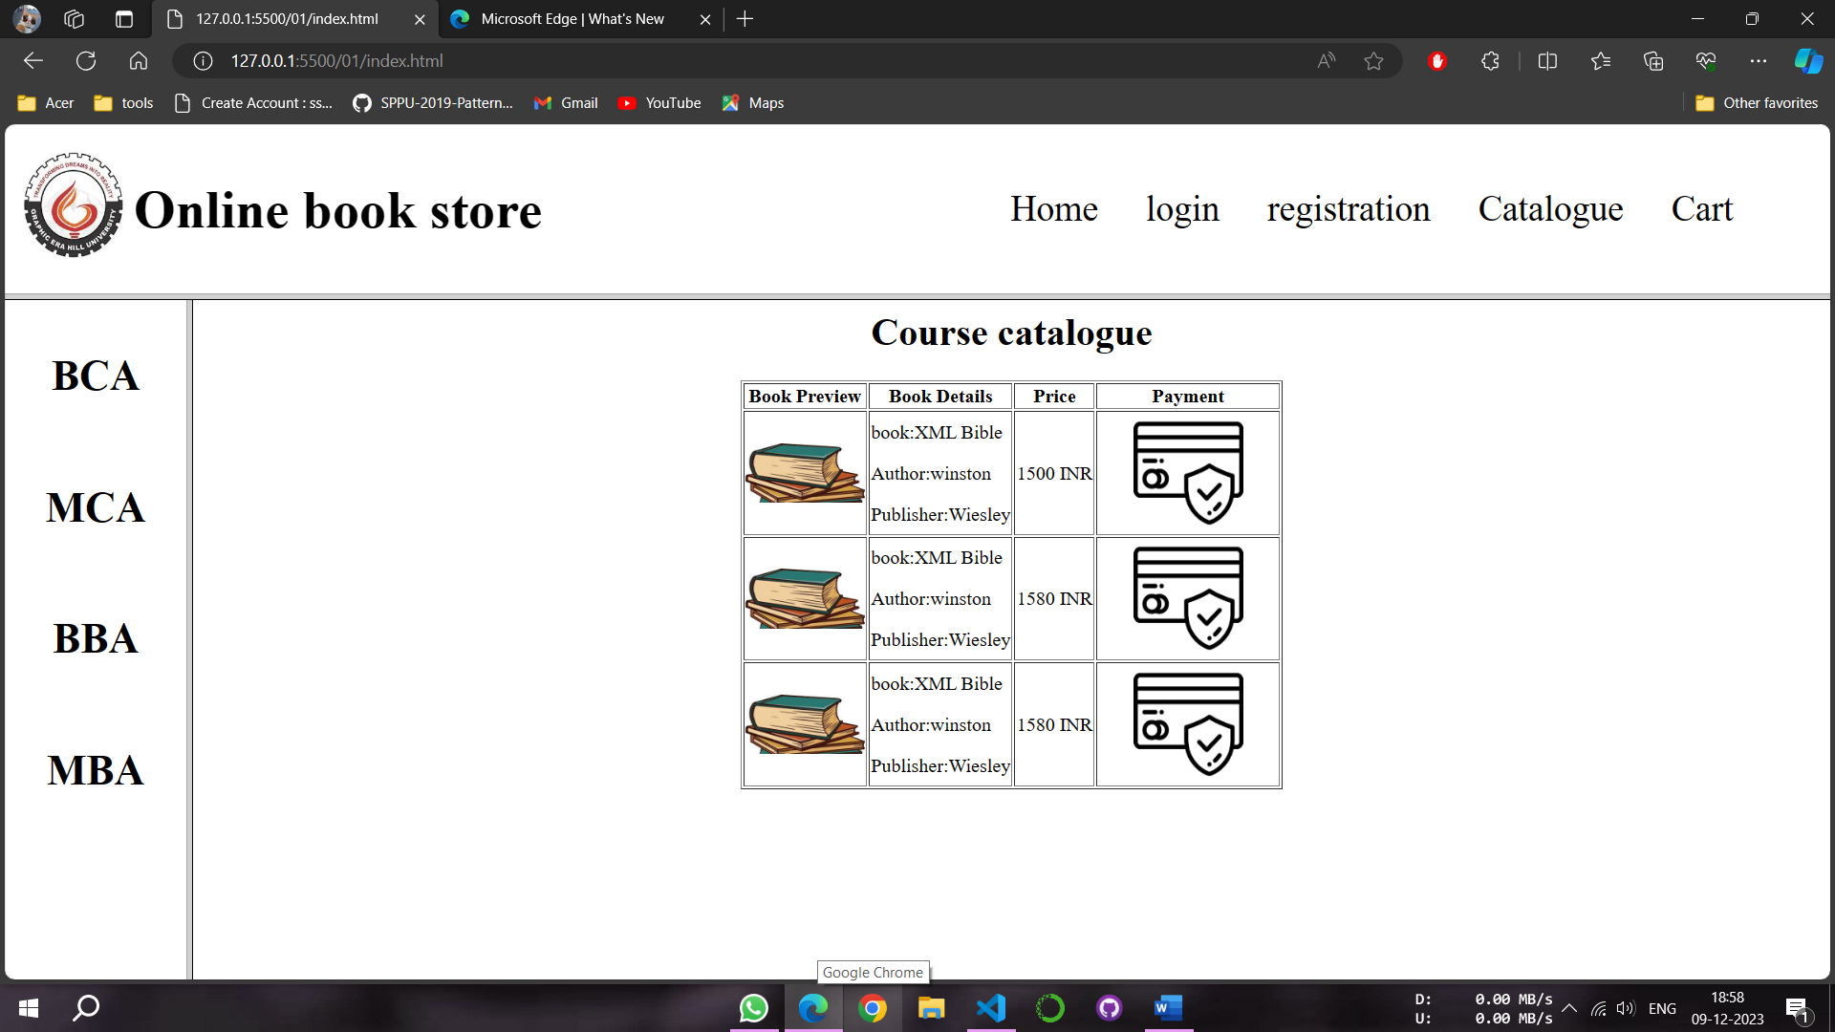

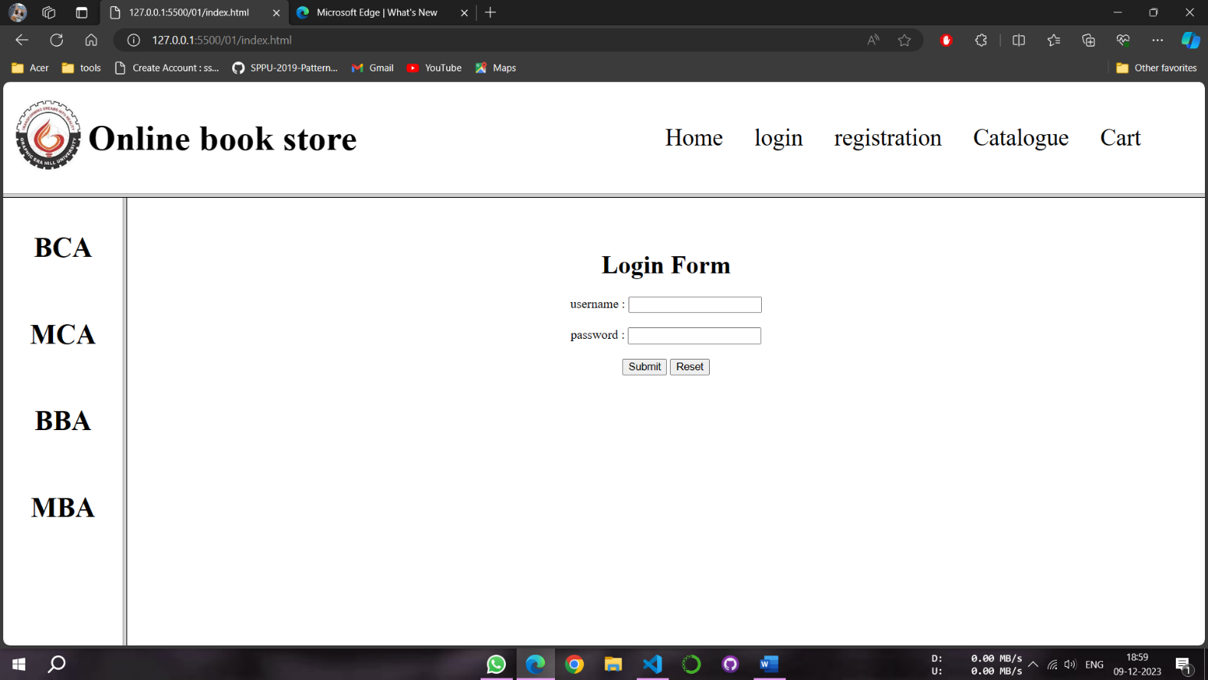

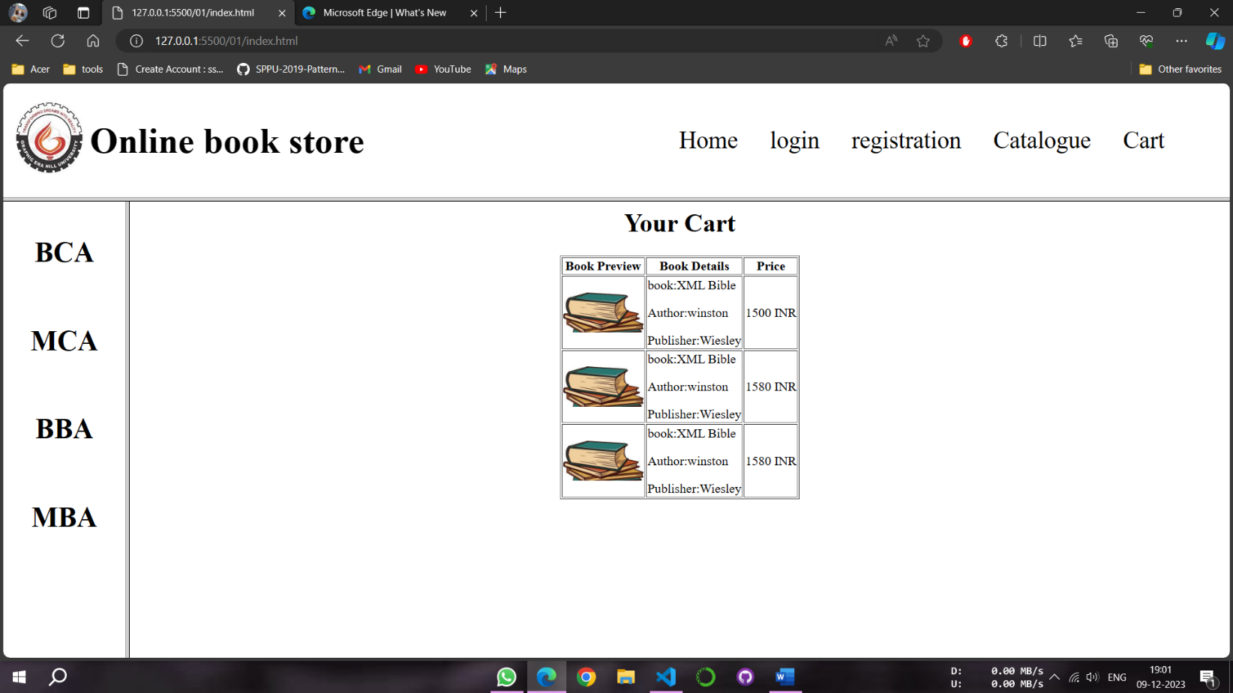

**PROGRAM 12**

NAME -Lalit singh

COURSE -MCA 1st Sem

ROLL NO -2351027

SUBJECT -Full Stack Development Laboratory (PMC-101)

1. **OBJECTIVE: To design a web page using CSS which includes the following:**
2. **Use different font styles**
3. **Set background image for both the page and single elements on page.**
4. **Control the repetition of image with background-repeat property**
5. **Define style for links as a: link, a: active, a: hover, a: visited**

**HTML CODE:**

<!DOCTYPE html>

<html lang="en">

<head>

<meta charset="UTF-8">

<meta name="viewport" content="width=device-width, initial-scale=1.0">

<title>Styled Web Page</title>

<style>

body {

font-family: 'Arial', sans-serif;

background-image: url('background.jpg');

background-repeat: no-repeat;

background-size: cover;

color: #ebe3e3;

}

h1{

font-family: 'Times New Roman', serif;

text-align: center;

background-color: #6c6969;

padding: 20px;

margin: 0;

}

p {

font-family: cursive;

line-height: 1.6;

text-align: center;

margin-bottom: 20px;

font-size: 25px;

color: rgb(197, 233, 174);

}

a:link{

color: red;

text-decoration: none;

}

a:visited {

color: green;

text-decoration: none;

}

a:hover{

color: hotpink;

text-decoration: underline;

}

a:active {

color: blue;

text-decoration: underline;

}

.button {

display: inline-block;

padding: 10px 20px;

background-color: #cce1cc;

color: rgb(68, 65, 65);

text-decoration: none;

border-radius: 5px;

margin: 40px;

font-size: 20px;

}

.special-element {

width: 400px;

height: 300px;

position: relative;

align-self: center;

background-image: url('eleback.jpg');

background-repeat: no-repeat;

background-size: cover;

padding: 50px;

color: white;

text-align: center;

margin-left: 35%;

border-radius: 20px;

}

</style>

</head>

<body>

<h1>Welcome to My Web Page</h1>

<p>This is a simple web page with different font styles and background images. Explore the links below:</p>

<ul>

<li><a href="#" class="button">Button Link</a></li>

</ul>

<div class="special-element">

<h2>Special Element</h2>

<p>This element has its own background image.</p>

<a href="#" class="button">Button Link</a>

</div>

</body>

</html>

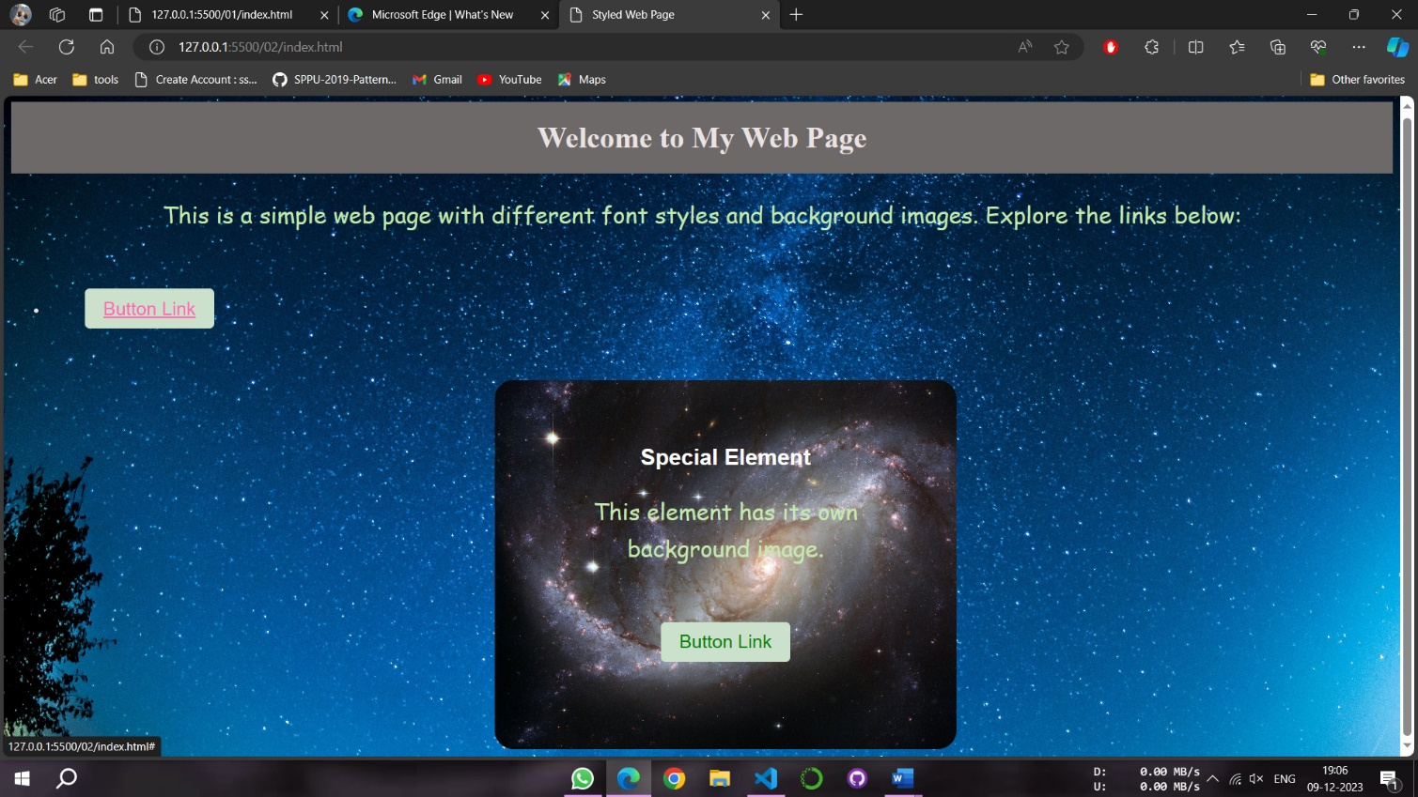**OUTPUT:**

**PROGRAM 13**

NAME -Lalit singh

COURSE -MCA 1st Sem

ROLL NO -2351027

SUBJECT -Full Stack Development Laboratory (PMC-101)

**OBJECTIVE: To Create a simple student bio-data form using html5. it should contain the following name (text box), address (multiline text box), gender (radio button male, female), skill sets known (check boxes – c, c++, java, C# etc), extracurricular activities (text box), nationality (combobox), submit and reset button.**

**HTML CODE:**

<!DOCTYPE html>

<html lang="en">

<head>

<meta charset="UTF-8">

<meta name="viewport" content="width=device-width, initial-scale=1.0">

<title>Student Bio-data Form</title>

<style>

body {

font-family: Arial, sans-serif;

margin: 20px;

}

form {

max-width: 400px;

margin: auto;

background-color: rgb(45, 143, 160);

border-radius: 10px;

padding: 40px;

}

label {

margin-bottom: 8px;

font-weight: bold;

}

.inputclass{

width: 100%;

padding: 8px;

margin-bottom: 16px;

box-sizing: border-box;

}

button {

background-color: #4CAF50;

color: white;

padding: 10px 15px;

border: none;

border-radius: 4px;

cursor: pointer;

}

button[type="reset"] {

background-color: #f44336;

}

form p{

display: flex;

flex-direction: row;

justify-content: space-between;

}

p input{

margin-right: 200px;

}

#head{

text-align: center;

}

</style>

</head>

<body>

<form action="#" method="post">

<h1 id="head">Student Bio Data</h1>

<label for="name"><h2>Name</h2></label>

<input type="text" class="inputclass" id="name" name="name" required>

<label for="address"><h2>Address</h2></label>

<textarea id="address" class="inputclass" name="address" rows="4" required></textarea>

<label><h2>Gender</h2></label>

<p>

<label for="male">Male</label>

<input type="radio" id="male" name="gender" value="male" required>

</p>

<p>

<label for="female">Female</label>

<input type="radio" id="female" name="gender" value="female" required>

</p>

<label><h2>Skill Sets Known:</h2></label>

<p>

<label for="c">C</label>

<input type="checkbox" id="c" name="skills" value="C">

</p>

<p>

<label for="cpp">C++</label>

<input type="checkbox" id="cpp" name="skills" value="C++">

</p>

<p>

<label for="java">Java</label>

<input type="checkbox" id="java" name="skills" value="Java">

</p>

<p>

<label for="csharp">C#</label>

<input type="checkbox" id="csharp" name="skills" value="C#">

</p>

<label for="extracurricular"><h2>Extracurricular Activities</h2></label>

<textarea id="extracurricular" class="inputclass" name="extracurricular" rows="4"></textarea>

<label for="nationality"><h2>Nationality</h2></label>

<select id="nationality" class="inputclass" name="nationality" required>

<option value="select">Select</option>

<option value="us">United States</option>

<option value="uk">United Kingdom</option>

<option value="india">India</option>

</select>

<button type="submit">Submit</button>

<button type="reset">Reset</button>

</form>

</body>

</html>

**OUTPUT:**

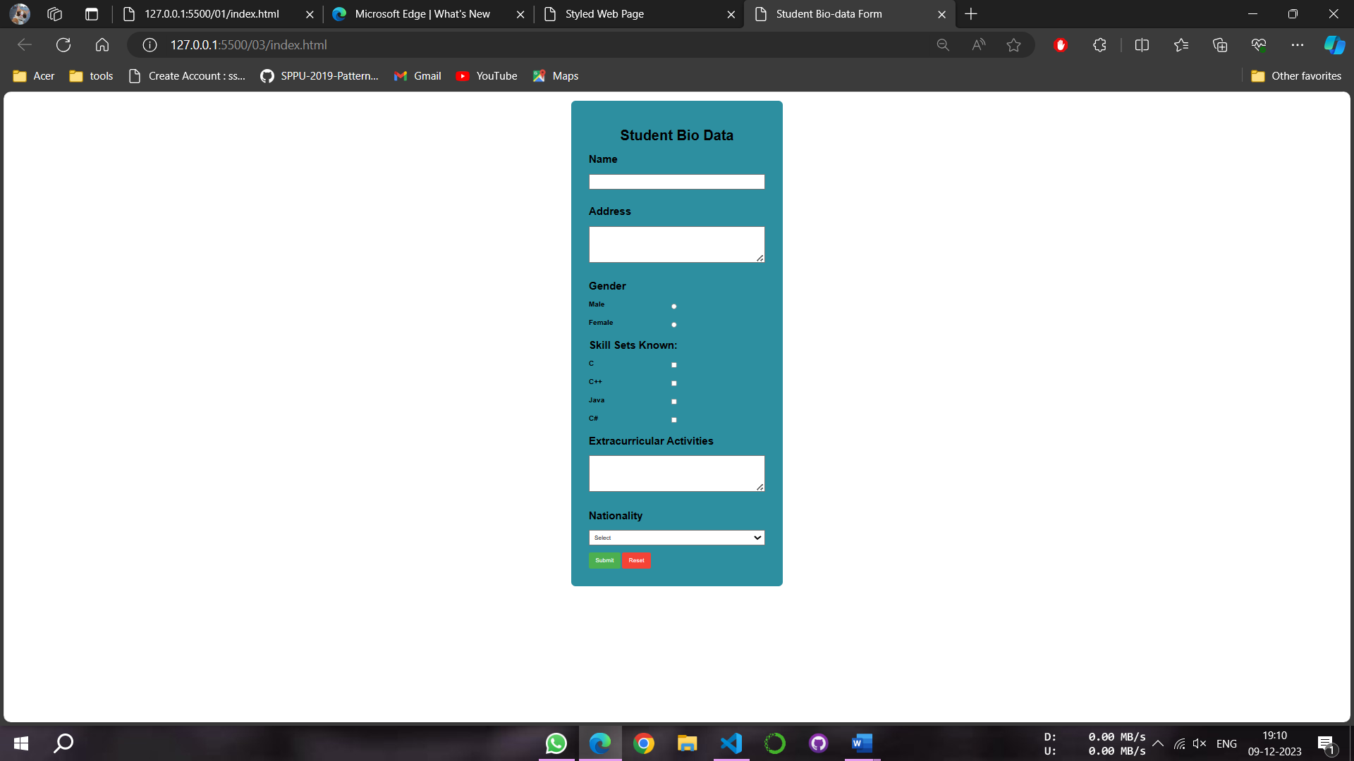

**PROGRAM 14**

NAME -Lalit singh

COURSE -MCA 1st Sem

ROLL NO -2351027

SUBJECT -Full Stack Development Laboratory (PMC-101)

**OBJECTIVE: Design the following static web pages required for an online bookstore web site.**

1. **HOME PAGE: The static home page must contain three frames.**
2. **LOGIN PAGE**
3. **CATOLOGUE PAGE: The catalogue page should contain the**
4. **details of all the books available in the web site in a table.**
5. **REGISTRATION PAGE**

**HTML CODE:**

1. **Index.html**

<!DOCTYPE html>

<html lang="en">

<head>

<meta charset="UTF-8">

<meta name="viewport" content="width=device-width, initial-scale=1.0">

<title>Online Bookstore - Home</title>

</head>

<frameset rows="50%,50%">

<frameset cols="50%,50%">

<frame src="header.html" name="header" scrolling="no" noresize>

<frame src="footer.html" name="footer" scrolling="no" noresize>

</frameset>

<frame src="content.html" name="main" scrolling="auto" noresize>

</frameset>

</html>

1. **Header.html**

<!DOCTYPE html>

<html lang="en">

<head>

<meta charset="UTF-8">

<meta name="viewport" content="width=device-width, initial-scale=1.0">

<title>Login - Online Bookstore</title>

<style>

body {

font-family: Arial, sans-serif;

background-color: #f4f4f4;

margin: 0;

display: flex;

align-items: center;

justify-content: center;

height: 100vh;

}

.login-container {

background-color: #fff;

border-radius: 8px;

box-shadow: 0 0 10px rgba(0, 0, 0, 0.1);

padding: 20px;

width: 300px;

text-align: center;

}

.login-container h2 {

color: #333;

}

.login-form {

margin-top: 20px;

}

.form-group {

margin-bottom: 15px;

}

.form-group label {

display: block;

font-weight: bold;

margin-bottom: 5px;

}

.form-group input {

width: 100%;

padding: 8px;

box-sizing: border-box;

border: 1px solid #ccc;

border-radius: 4px;

}

.form-group input[type="submit"] {

background-color: #4caf50;

color: #fff;

cursor: pointer;

}

.form-group input[type="submit"]:hover {

background-color: #45a049;

}

</style>

</head>

<body>

<div class="login-container">

<h2>Login</h2>

<form class="login-form" action="login.php" method="post">

<div class="form-group">

<label for="username">Username:</label>

<input type="text" id="username" name="username" required>

</div>

<div class="form-group">

<label for="password">Password:</label>

<input type="password" id="password" name="password" required>

</div>

<div class="form-group">

<input type="submit" value="Login">

</div>

</form>

</div>

</body>

</html>

1. **Footer.html**

<!DOCTYPE html>

<html lang="en">

<head>

<meta charset="UTF-8">

<meta name="viewport" content="width=device-width, initial-scale=1.0">

<title>Register - Online Bookstore</title>

<style>

body {

font-family: Arial, sans-serif;

background-color: #f4f4f4;

margin: 0;

display: flex;

align-items: center;

justify-content: center;

height: 100vh;

}

.register-container {

background-color: #fff;

border-radius: 8px;

box-shadow: 0 0 10px rgba(0, 0, 0, 0.1);

padding: 20px;

width: 300px;

text-align: center;

}

.register-container h2 {

color: #333;

}

.register-form {

margin-top: 20px;

}

.form-group {

margin-bottom: 15px;

}

.form-group label {

display: block;

font-weight: bold;

margin-bottom: 5px;

}

.form-group input {

width: 100%;

padding: 8px;

box-sizing: border-box;

border: 1px solid #ccc;

border-radius: 4px;

}

.form-group input[type="submit"] {

background-color: #4caf50;

color: #fff;

cursor: pointer;

}

.form-group input[type="submit"]:hover {

background-color: #45a049;

}

</style>

</head>

<body>

<div class="register-container">

<h2>Register</h2>

<form class="register-form" action="register.php" method="post">

<div class="form-group">

<label for="username">Username:</label>

<input type="text" id="username" name="username" required>

</div>

<div class="form-group">

<label for="password">Password:</label>

<input type="password" id="password" name="password" required>

</div>

<div class="form-group">

<label for="email">Email:</label>

<input type="email" id="email" name="email" required>

</div>

<div class="form-group">

<input type="submit" value="Register">

</div>

</form>

</div>

</body>

</html>

1. **Content.html**

<!DOCTYPE html>

<html lang="en">

<head>

<meta charset="UTF-8">

<meta name="viewport" content="width=device-width, initial-scale=1.0">

<title>Course Catalog - Online Bookstore</title>

<style>

body {

font-family: Arial, sans-serif;

background-color: #f4f4f4;

margin: 0;

padding: 20px;

box-sizing: border-box;

}

.catalog-container {

background-color: #fff;

border-radius: 8px;

box-shadow: 0 0 10px rgba(0, 0, 0, 0.1);

padding: 20px;

text-align: center;

}

.catalog-container h2 {

color: #333;

}

table {

width: 100%;

border-collapse: collapse;

margin-top: 20px;

}

th, td {

border: 1px solid #ddd;

padding: 8px;

text-align: left;

}

th {

background-color: #f2f2f2;

}

</style>

</head>

<body>

<div class="catalog-container">

<h2>Book Catologue</h2>

<table>

<thead>

<tr>

<th>Book Code</th>

<th>book Title</th>

<th>Writer</th>

<th>Price</th>

</tr>

</thead>

<tbody>

<tr>

<td>CSCI 101</td>

<td>Introduction to Computer Science</td>

<td>abc</td>

<td>1500</td>

</tr>

<tr>

<td>MATH 201</td>

<td>Calculus I</td>

<td>abc</td>

<td>1800</td>

</tr>

<tr>

<td>CSCI 101</td>

<td>Introduction to Computer Science</td>

<td>abc</td>

<td>1500</td>

</tr>

<tr>

<td>MATH 201</td>

<td>Calculus I</td>

<td>abc</td>

<td>1800</td>

</tr>

<tr>

<td>CSCI 101</td>

<td>Introduction to Computer Science</td>

<td>abc</td>

<td>1500</td>

</tr>

<tr>

<td>MATH 201</td>

<td>Calculus I</td>

<td>abc</td>

<td>1800</td>

</tr>

</tbody>

</table>

</div>

</body>

</html>

1. **Style.css**

*{

color: black;

}

.topnav{

display: flex;

flex-direction: row;

align-items: center;

}

.topul{

display: flex;

flex-direction: row;

margin-left: 22rem;

}

.topul li{

margin-left: 40px;

font-size: 30px;

}

nav img{

width: 100px;

height: 100px;

}

h1{

font-size: 45px;

}

ul{

list-style: none;

padding: 0;

}

a{

text-decoration: none;

}

p{

font-size: 30px;

padding: 20px;

text-align: justify;

}

.leftnav{

display: flex;

flex-direction: column;

font-size: 30px;

align-items: center;

}

**OUTPUT:**

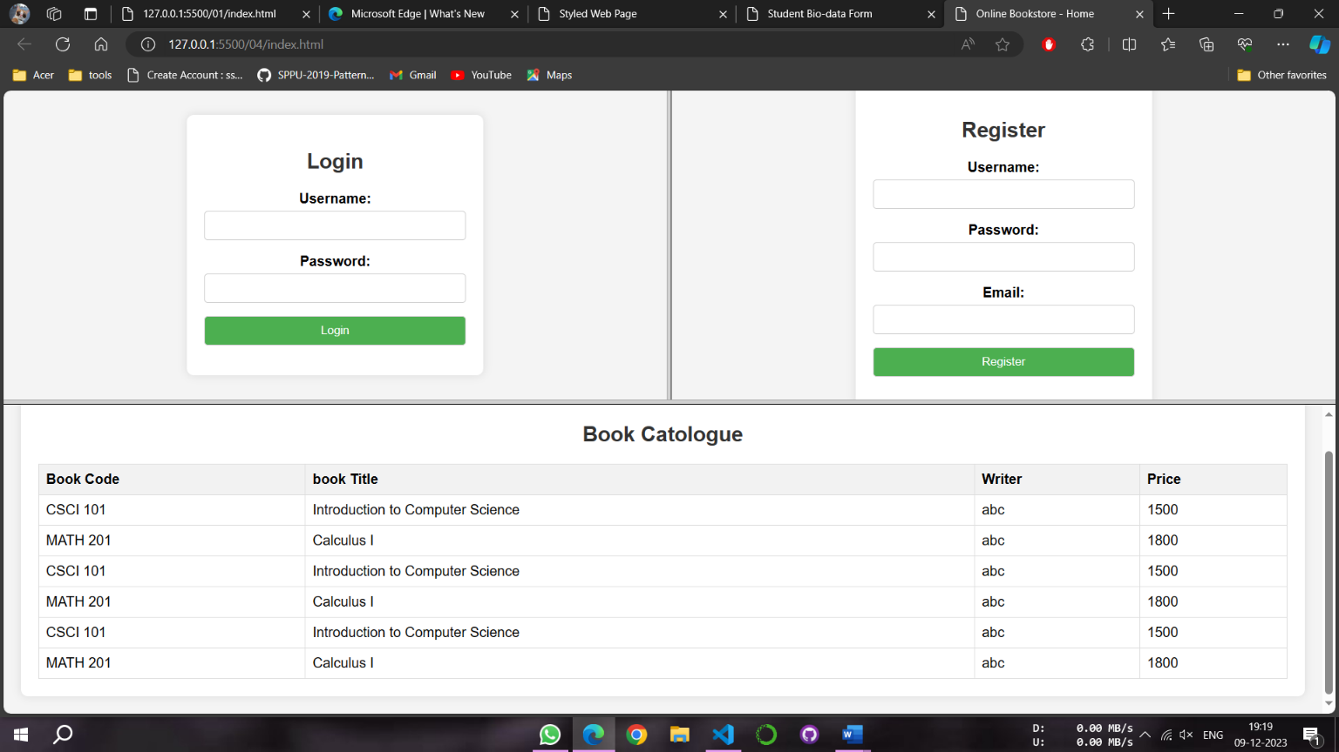

**PROGRAM 15**

NAME -Lalit singh

COURSE -MCA 1st Sem

ROLL NO -2351027

SUBJECT -Full Stack Development Laboratory (PMC-101)

**OBJECTIVE: To validate the following fields of the Registration page.**

1. **First Name (Name should contains alphabets and the length**

**should not be less than 6 characters).**

1. **Password (Password should not be less than 6 characters length).**
2. **E-mail id (should not contain any invalid and must follow the**

**standard pattern name@domain.com)**

1. **Mobile Number (Phone number should contain 10 digits only).**
2. **Last Name and Address (should not be Empty).**

**HTML CODE:**

<!DOCTYPE html>

<html lang="en">

<head>

<meta charset="UTF-8">

<meta name="viewport" content="width=device-width, initial-scale=1.0">

<title>Registration Page</title>

<style>

body {

font-family: Arial, sans-serif;

background-color: #f4f4f4;

margin: 0;

padding: 0;

display: flex;

justify-content: center;

align-items: center;

height: 100vh;

}

form {

background-color: #fff;

padding: 20px;

border-radius: 8px;

box-shadow: 0 0 10px rgba(0, 0, 0, 0.1);

width: 300px;

}

label {

display: block;

margin-bottom: 8px;

}

input,

textarea {

width: 100%;

padding: 8px;

margin-bottom: 12px;

box-sizing: border-box;

border: 1px solid #ccc;

border-radius: 4px;

}

input[type="submit"] {

background-color: #4caf50;

color: #fff;

cursor: pointer;

}

input[type="submit"]:hover {

background-color: #45a049;

}

.error {

color: red;

margin-bottom: 10px;

}

</style>

<script>

function validateForm() {

var firstName = document.getElementById('firstName').value;

var password = document.getElementById('password').value;

var email = document.getElementById('email').value;

var mobileNumber = document.getElementById('mobileNumber').value;

var lastName = document.getElementById('lastName').value;

var address = document.getElementById('address').value;

if (!/^[a-zA-Z]{6,}$/.test(firstName)) {

alert('First Name should contain alphabets and be at least 6 characters long.');

return false;

}

if (password.length < 6) {

alert('Password should be at least 6 characters long.');

return false;

}

var emailPattern = /^[^\s@]+@[^\s@]+\.[^\s@]+$/;

if (!emailPattern.test(email)) {

alert('Invalid email format. Please use name@domain.com.');

return false;

}

if (!/^\d{10}$/.test(mobileNumber)) {

alert('Mobile Number should contain 10 digits only.');

return false;

}

if (lastName.trim() === '' || address.trim() === '') {

alert('Last Name and Address should not be empty.');

return false;

}

alert('Form submitted successfully!');

return true;

}

</script>

</head>

<body>

<form onsubmit="return validateForm()">

<label for="firstName">First Name:</label>

<input type="text" id="firstName" name="firstName" ><br>

<label for="password">Password:</label>

<input type="password" id="password" name="password" ><br>

<label for="email">E-mail:</label>

<input type="email" id="email" name="email"><br>

<label for="mobileNumber">Mobile Number:</label>

<input type="text" id="mobileNumber" name="mobileNumber"><br>

<label for="lastName">Last Name:</label>

<input type="text" id="lastName" name="lastName" ><br>

<label for="address">Address:</label>

<textarea id="address" name="address" rows="4" cols="50" ></textarea><br>

<input type="submit" value="Submit">

</form>

</body>

</html>

**OUTPUT:**

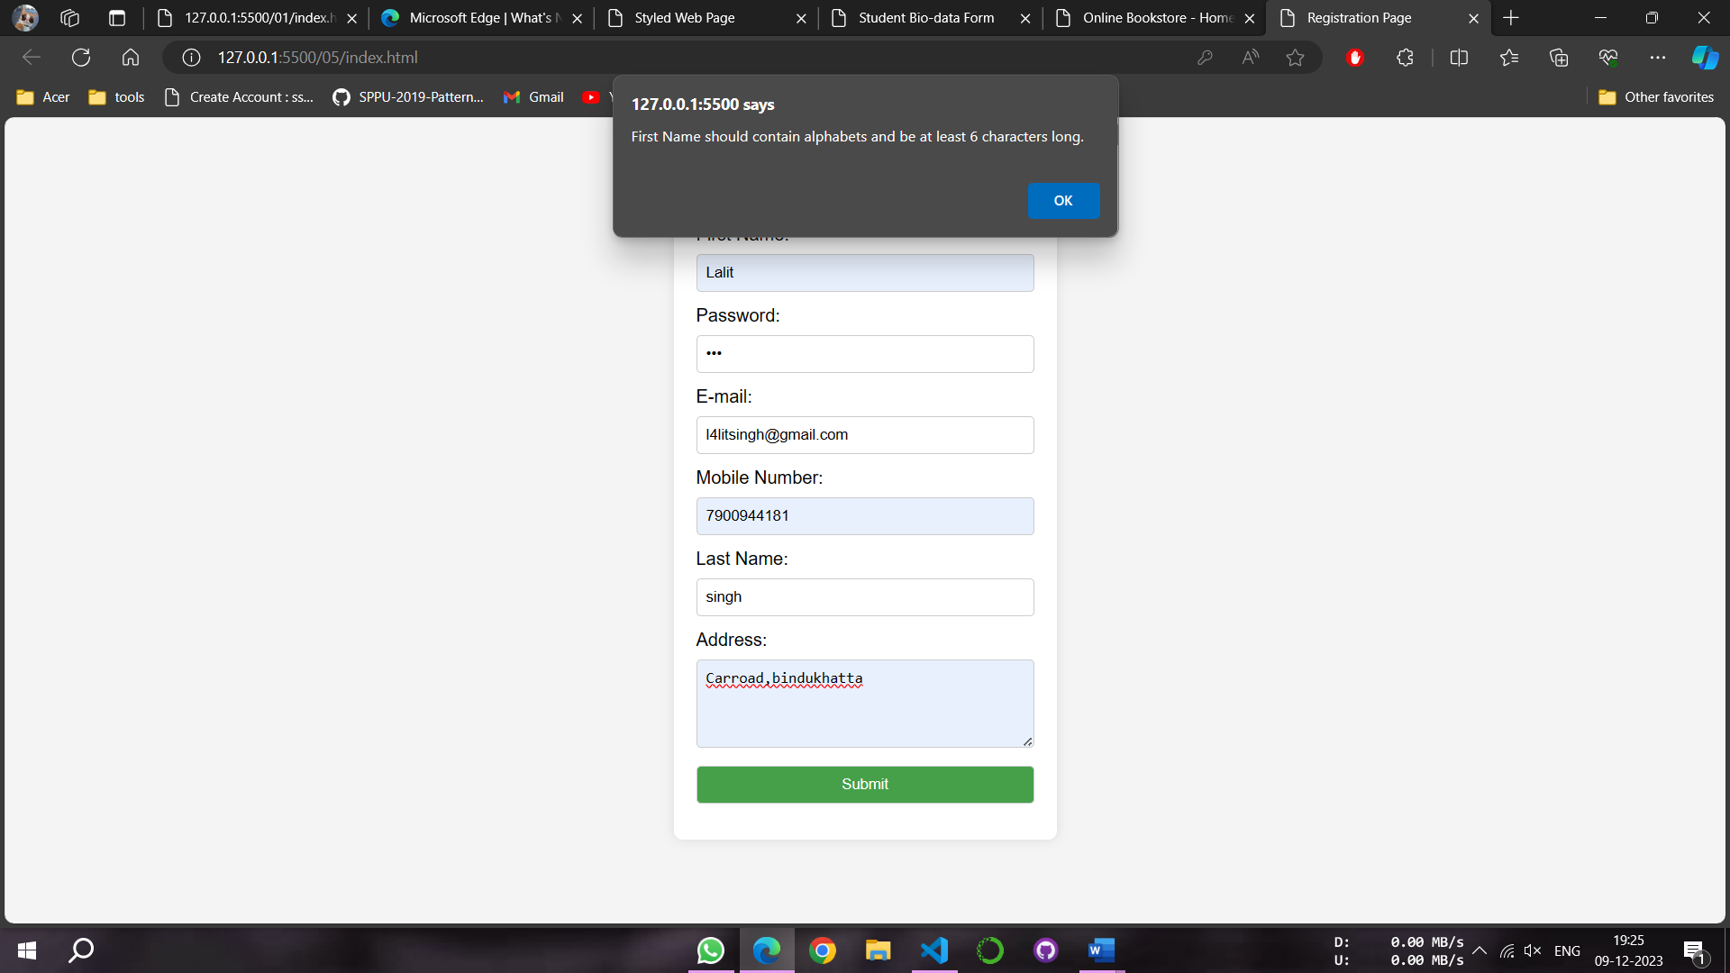

**PROGRAM 16**

NAME -Lalit singh

COURSE -MCA 1st Sem

ROLL NO -2351027

SUBJECT -Full Stack Development Laboratory (PMC-101)

**OBJECTIVE: To demonstrate the usage of inline, internal, and external style sheet using CSS.**

**HTML CODE:**

1. **Index.html**

<!DOCTYPE html>

<html lang="en">

<head>

<meta charset="UTF-8">

<meta name="viewport" content="width=device-width, initial-scale=1.0">

<title>CSS Styles</title>

<style>

h2 {

color: green;

}

p {

font-size: 18px;

}

</style>

<link rel="stylesheet" href="style.css">

</head>

<body>

<div style="background-color: blanchedalmond;">

<h1 style="color: blue;"> Inline Style Css</h1>

<p>

Lorem ipsum dolor sit amet, consectetur adipisicing elit. Necessitatibus dolorem maxime blanditiis fuga saepe quas praesentium, rerum expedita fugiat. Quisquam saepe tempore nobis, a nisi odit laborum unde ut velit.

</p>

<h1 style="color: blue;">This is a Heading with Inline Style</h1>

<p>

Lorem ipsum dolor sit amet, consectetur adipisicing elit. Necessitatibus dolorem maxime blanditiis fuga saepe quas praesentium, rerum expedita fugiat. Quisquam saepe tempore nobis, a nisi odit laborum unde ut velit.

</p>

</div>

<div>

<h1>Internal CSS</h1>

<h2>This is a Heading with Internal Style</h2>

<p>Lorem ipsum dolor sit, amet consectetur adipisicing elit. Corrupti ex ipsum dolor minus, repudiandae eum at qui commodi consectetur nobis deserunt explicabo corporis placeat! Ad iure laudantium sequi debitis qui!</p></div>

<div>

<h1>External Css</h1>

<h3>This is a Heading with External Style</h3>

<P>Lorem ipsum dolor sit amet consectetur adipisicing elit. Architecto similique unde mollitia eius neque! Sint illo minus tenetur in unde aspernatur, voluptate eveniet architecto, quod dolor nostrum, culpa ullam officiis?</P>

</div>

</body>

</html>

1. **Style.css**

h3 {

color: purple;

}

div {

border: 2px solid #333;

padding: 10px;

margin: 20px;

}

**OUTPUT:**

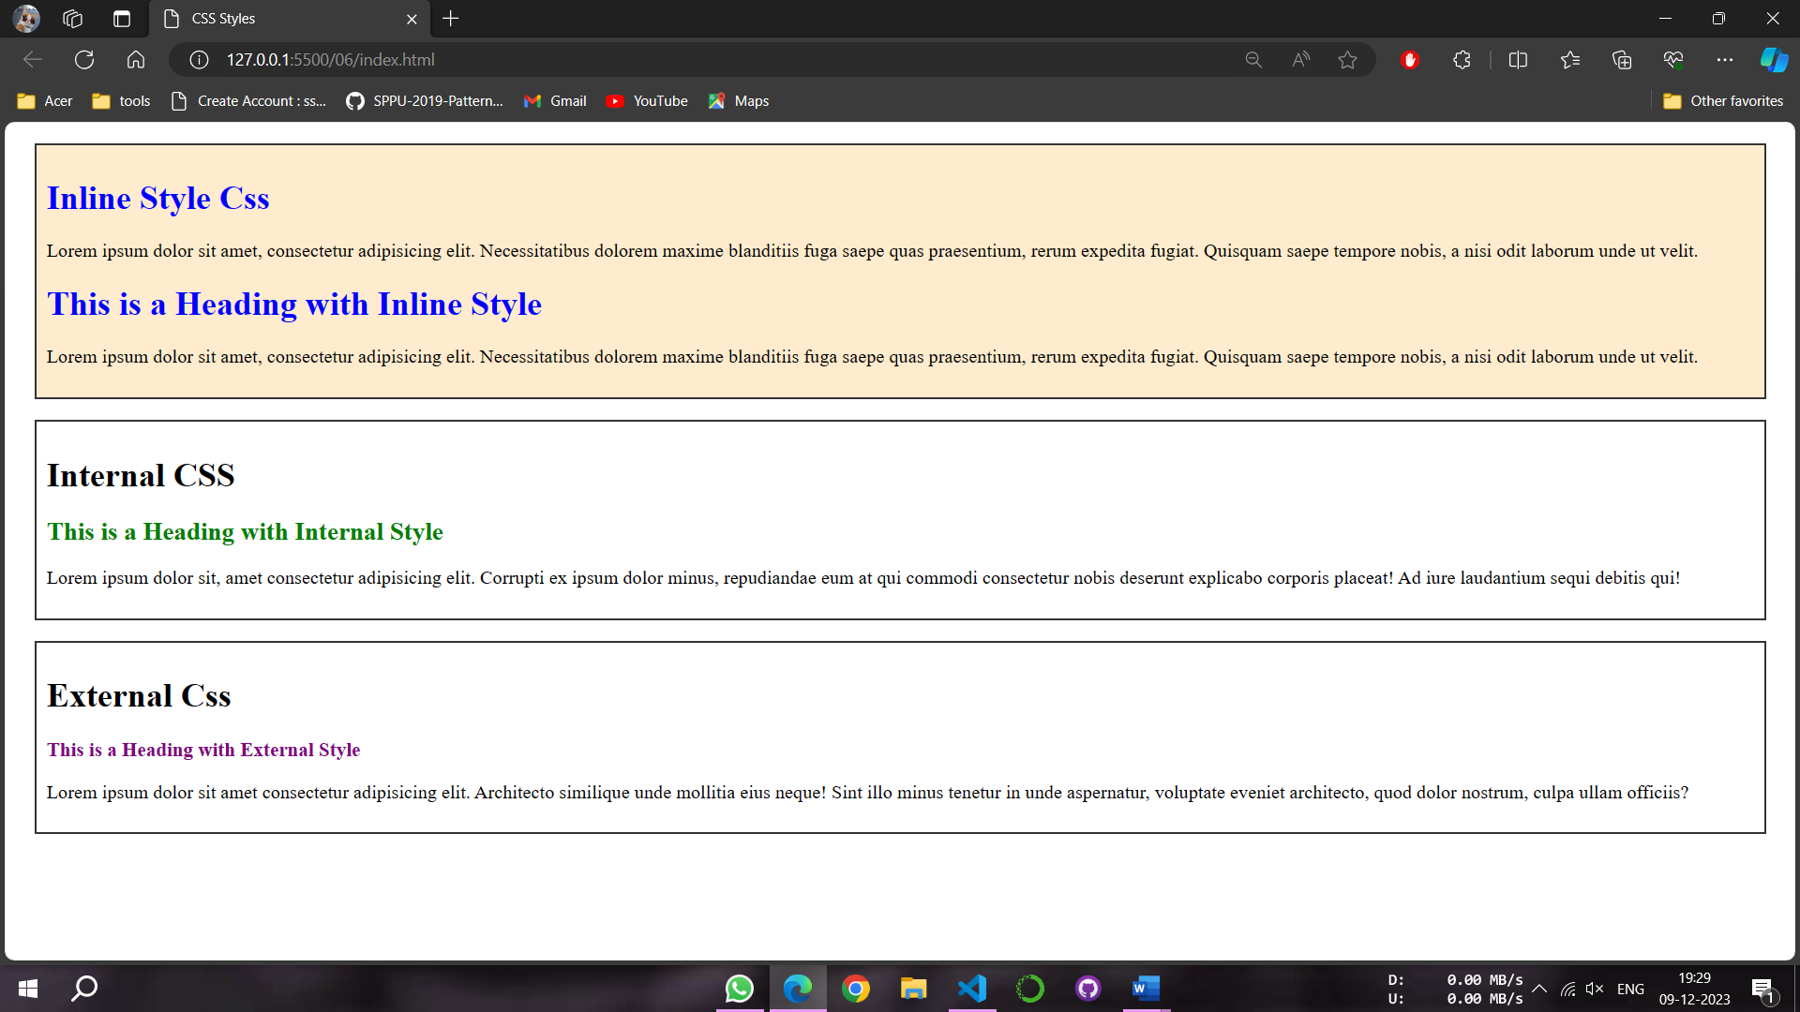

**PROGRAM 17**

NAME -Lalit singh

COURSE -MCA 1st Sem

ROLL NO -2351027

SUBJECT -Full Stack Development Laboratory (PMC-101)

**OBJECTIVE: To Write a PHP program to store current date-time in a COOKIE and display the ‘Last visited on’ date-time on the web page upon reopening of the same page.**

**PhP CODE:**

<?php

function setVisitCookie() {

$cookie_name = "last_visited";

$current_date_time = date("Y-m-d H:i:s");

setcookie($cookie_name, $current_date_time, time() + (86400 * 30), "/"); // Cookie set to expire in 30 days

}

if (!isset($_COOKIE["last_visited"])) {

setVisitCookie();

} else {

$last_visited = $_COOKIE["last_visited"];

echo "Last visited on: " . $last_visited;

setVisitCookie();

}

?>

<!DOCTYPE html>

<html lang="en">

<head>

<meta charset="UTF-8">

<meta name="viewport" content="width=device-width, initial-scale=1.0">

<title>Last Visited Example</title>

</head>

<body>

<h1>Welcome to the Page</h1>

<p>This page will display the last visited date and time.</p>

</body>

</html>

**OUTPUT:**

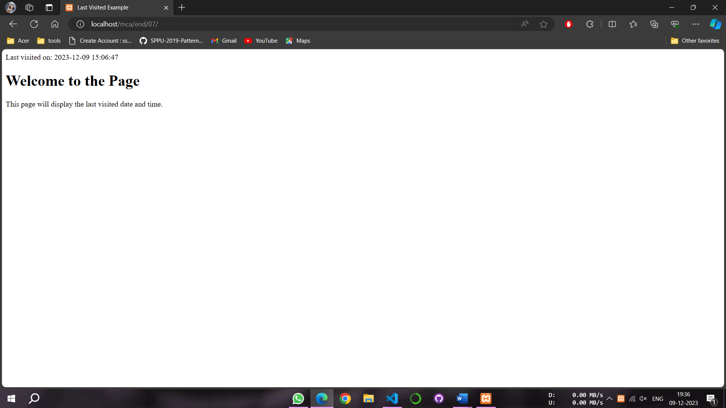

**PROGRAM 18**

NAME -Lalit singh

COURSE -MCA 1st Sem

ROLL NO -2351027

SUBJECT -Full Stack Development Laboratory (PMC-101)

**OBJECTIVE: To write a PHP program to store page views count in SESSION, to increment the count on each refresh, and to show the count on web page.**

**PhP CODE:**

<?php

session_start();

if (!isset($_SESSION['page_views'])) {

$_SESSION['page_views'] = 1;

} else {

$_SESSION['page_views']++;

}

$page_views = $_SESSION['page_views'];

echo "Page views: " . $page_views;

?>

<!DOCTYPE html>

<html lang="en">

<head>

<meta charset="UTF-8">

<meta name="viewport" content="width=device-width, initial-scale=1.0">

<title>Page Views Example</title>

</head>

<body>

<h1>Welcome to the Page</h1>

<p>This page has been visited <?php echo $page_views; ?> times.</p>

</body>

</html>

**OUTPUT:**

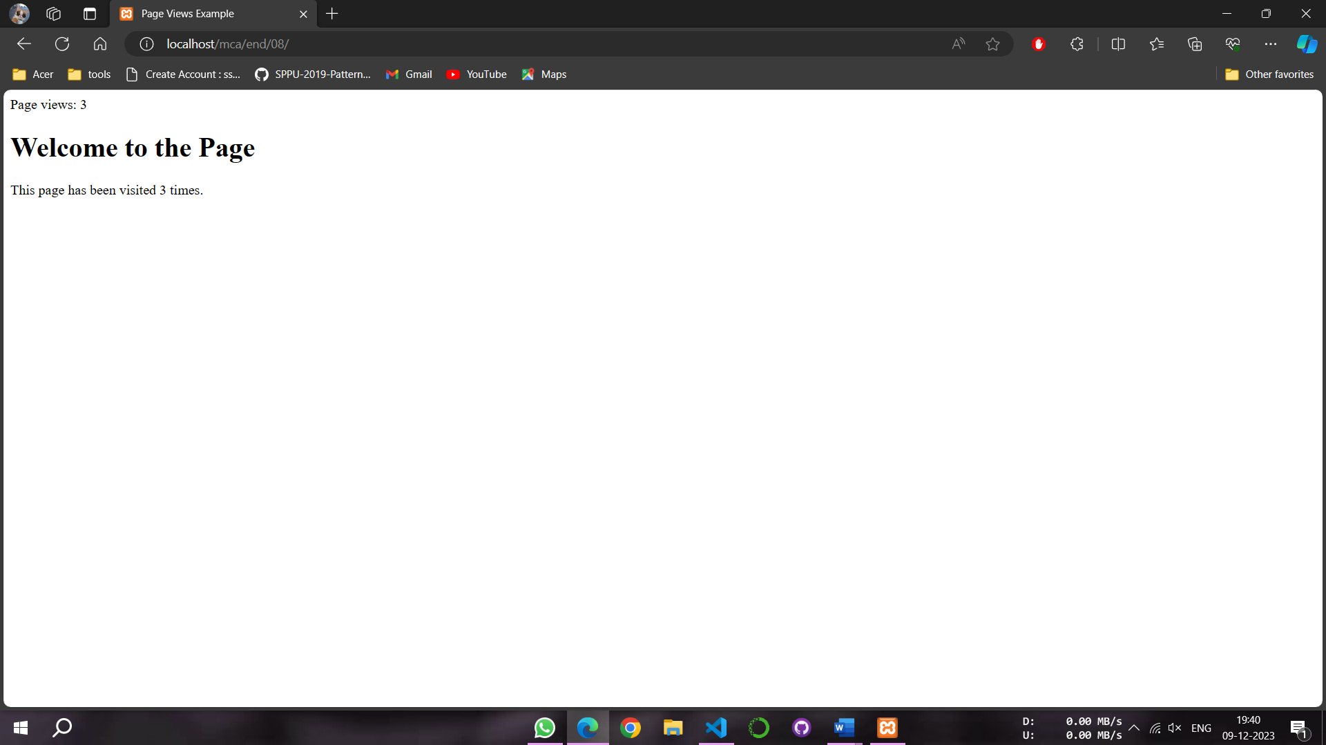

**PROGRAM 19**

NAME -Lalit singh

COURSE -MCA 1st Sem

ROLL NO -2351027

SUBJECT -Full Stack Development Laboratory (PMC-101)

**OBJECTIVE: To create a HTML form, add the data into it and submit it to the database by connecting it to MySQL database using PHP.**

**PhP CODE:**

1. **Index.php**

<!DOCTYPE html>

<html lang="en">

<head>

<meta charset="UTF-8">

<meta name="viewport" content="width=device-width, initial-scale=1.0">

<title>User Registration Form</title>

<style>

body {

font-family: Arial, sans-serif;

background-color: #f4f4f4;

margin: 0;

display: flex;

flex-direction: column;

align-items: center;

justify-content: center;

height: 100vh;

}

h1 {

text-align: center;

color: #333;

}

form {

background-color: #fff;

border-radius: 8px;

box-shadow: 0 0 10px rgba(0, 0, 0, 0.1);

padding: 20px;

width: 300px;

text-align: center;

}

label {

display: block;

margin: 10px 0;

color: #333;

}

input {

width: 100%;

padding: 8px;

box-sizing: border-box;

margin-bottom: 15px;

}

input[type="submit"] {

background-color: #4caf50;

color: #fff;

cursor: pointer;

}

input[type="submit"]:hover {

background-color: #45a049;

}

</style>

</head>

<body>

<h1>User Registration Form</h1>

<form action="abc.php" method="post">

<label for="name">Name:</label>

<input type="text" id="name" name="name" required>

<label for="name">Password:</label>

<input type="password" id="pass" name="pass" required>

<label for="email">Email:</label>

<input type="email" id="email" name="email" required>

<label for="email">age:</label>

<input type="number" id="age" name="age" required>

<input type="submit" value="Submit">

</form>

</body>

</html>

1. **Abc.php**

<?php

$servername = "localhost";

$username = "root";

$password = "";

$dbname = "mca";

$conn = new mysqli($servername, $username, $password, $dbname);

if ($conn->connect_error) {

die("Connection failed: " . $conn->connect_error);

}

$name = $_POST["name"];

$email = $_POST["email"];

$pass = $_POST["pass"];

$age = $_POST["age"];

$sql = "INSERT INTO users (name, email, age, pass) VALUES ('$name', '$email', '$age', '$pass')";

if ($conn->query($sql) === TRUE) {

echo "New record created successfully";

echo "<h2>Records in the Database</h2>";

echo "<table border='1'>";

echo "<tr><th>Name</th><th>Email</th><th>Age</th><th>Password</th></tr>";

$selectQuery = "SELECT * FROM users";

$result = $conn->query($selectQuery);

if ($result->num_rows > 0) {

while ($row = $result->fetch_assoc()) {

echo "<tr><td>" . $row["name"] . "</td><td>" . $row["email"] . "</td><td>" . $row["age"] . "</td><td>" . $row["pass"] . "</td></tr>";

}

} else {

echo "<tr><td colspan='4'>No records found</td></tr>";

}

echo "</table>";

} else {

echo "Error: " . $sql . "<br>" . $conn->error;

}

$conn->close();

?>

**OUTPUT:**

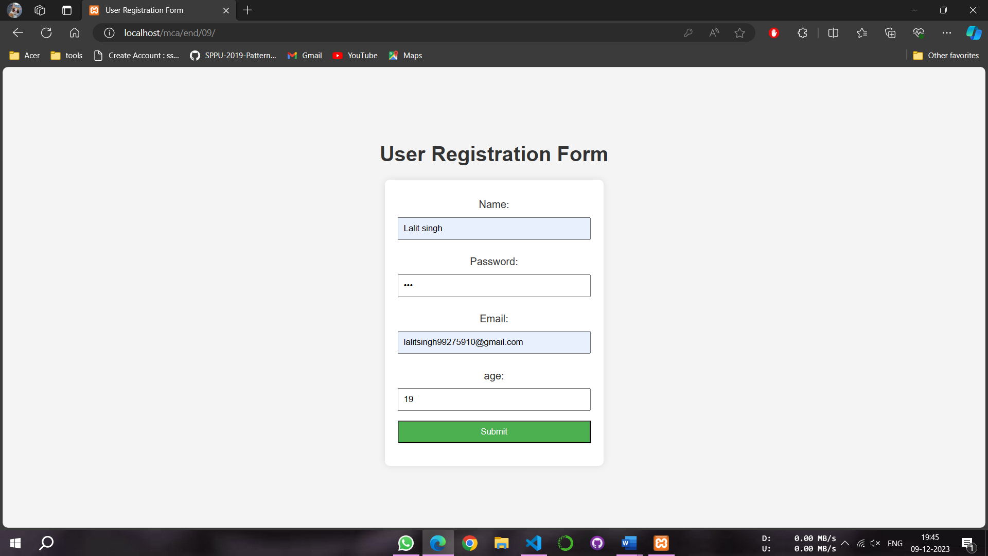

**PROGRAM 20**

NAME -Lalit singh

COURSE -MCA 1st Sem

ROLL NO -2351027

SUBJECT -Full Stack Development Laboratory (PMC-101)

**OBJECTIVE: To create a basic CRUD application using PHP and MySQL.**

**PhP CODE:**

1. **Index.php**

<!DOCTYPE html>

<html lang="en">

<head>

<meta charset="UTF-8">

<meta name="viewport" content="width=device-width, initial-scale=1.0">

<title>CRUD Application - List Records</title>

</head>

<body>

<h2>List of Users</h2>

<?php

$servername = "localhost";

$username = "root";

$password = "";

$dbname = "mca";

$conn = new mysqli($servername, $username, $password, $dbname);

if ($conn->connect_error) {

die("Connection failed: " . $conn->connect_error);

}

$selectQuery = "SELECT * FROM users";

$result = $conn->query($selectQuery);

if ($result->num_rows > 0) {

echo "<table border='1'>";

echo "<tr><th>Name</th><th>Email</th><th>Age</th><th>Password</th><th>Action</th></tr>";

while ($row = $result->fetch_assoc()) {

echo "<tr>";

echo "<td>" . $row["name"] . "</td>";

echo "<td>" . $row["email"] . "</td>";

echo "<td>" . $row["age"] . "</td>";

echo "<td>" . $row["pass"] . "</td>";

echo "<td><a href='edit.php?email=" . $row["email"] . "'>Edit</a> | <a href='delete.php?email=" . $row["email"] . "'>Delete</a></td>";

echo "</tr>";

}

echo "</table>";

} else {

echo "No records found";

}

$conn->close();

?>

<p><a href="add.php">Add New User</a></p>

</body>

</html>

1. **Update.php**

<?php

$servername = "localhost";

$username = "root";

$password = "";

$dbname = "mca";

$conn = new mysqli($servername, $username, $password, $dbname);

if ($conn->connect_error) {

die("Connection failed: " . $conn->connect_error);

}

$email = $_POST["email"];

$name = $_POST["name"];

$pass = $_POST["pass"];

$age = $_POST["age"];

$sql = "UPDATE users SET name='$name', age='$age', pass='$pass' WHERE email='$email'";

if ($conn->query($sql) === TRUE) {

echo "Record updated successfully";

} else {

echo "Error updating record: " . $conn->error;

}

$conn->close();

header("Location: index.php"); // Redirect to the list after updating the record

exit();

?>

1. **Insert.php**

<?php

$servername = "localhost";

$username = "root";

$password = "";

$dbname = "mca";

$conn = new mysqli($servername, $username, $password, $dbname);

if ($conn->connect_error) {

die("Connection failed: " . $conn->connect_error);

}

$name = $_POST["name"];

$email = $_POST["email"];

$pass = $_POST["pass"];

$age = $_POST["age"];

$sql = "INSERT INTO users (name, email, age, pass) VALUES ('$name', '$email', '$age', '$pass')";

if ($conn->query($sql) === TRUE) {

echo "New record created successfully";

} else {

echo "Error: " . $sql . "<br>" . $conn->error;

}

$conn->close();

header("Location: index.php"); // Redirect to the list after adding a new record

exit();

?>

1. **Edit.php**

<!DOCTYPE html>

<html lang="en">

<head>

<meta charset="UTF-8">

<meta name="viewport" content="width=device-width, initial-scale=1.0">

<title>CRUD Application - Edit User</title>

</head>

<body>

<h2>Edit User</h2>

<?php

$servername = "localhost";

$username = "root";

$password = "";

$dbname = "mca";

$conn = new mysqli($servername, $username, $password, $dbname);

if ($conn->connect_error) {

die("Connection failed: " . $conn->connect_error);

}

$email = $_GET["email"];

$selectQuery = "SELECT * FROM users WHERE email = '$email'";

$result = $conn->query($selectQuery);

if ($result->num_rows > 0) {

$row = $result->fetch_assoc();

?>

<form action="update.php" method="post">

<input type="hidden" name="email" value="<?php echo $row['email']; ?>">

<label for="name">Name:</label>

<input type="text" id="name" name="name" value="<?php echo $row['name']; ?>" required>

<br>

<label for="age">Age:</label>

<input type="number" id="age" name="age" value="<?php echo $row['age']; ?>" required>

<br>

<label for="pass">Password:</label>

<input type="password" id="pass" name="pass" value="<?php echo $row['pass']; ?>" required>

<br>

<input type="submit" value="Update User">

</form>

<?php

} else {

echo "No record found";

}

$conn->close();

?>

<p><a href="index.php">Back to List</a></p>

</body>

</html>

1. **Add.php**

<!DOCTYPE html>

<html lang="en">

<head>

<meta charset="UTF-8">

<meta name="viewport" content="width=device-width, initial-scale=1.0">

<title>CRUD Application - Add User</title>

</head>

<body>

<h2>Add New User</h2>

<form action="insert.php" method="post">

<label for="name">Name:</label>

<input type="text" id="name" name="name" required>

<br>

<label for="email">Email:</label>

<input type="email" id="email" name="email" required>

<br>

<label for="age">Age:</label>

<input type="number" id="age" name="age" required>

<br>

<label for="pass">Password:</label>

<input type="password" id="pass" name="pass" required>

<br>

<input type="submit" value="Add User">

</form>

<p><a href="index.php">Back to List</a></p>

</body>

</html>

1. **Delete.php**

<?php

$servername = "localhost";

$username = "root";

$password = "";

$dbname = "mca";

$conn = new mysqli($servername, $username, $password, $dbname);

if ($conn->connect_error) {

die("Connection failed: " . $conn->connect_error);

}

$email = $_GET["email"];

$sql = "DELETE FROM users WHERE email='$email'";

if ($conn->query($sql) === TRUE) {

echo "Record deleted successfully";

} else {

echo "Error deleting record: " . $conn->error;

}

$conn->close();

header("Location: index.php");

exit();

?>

**OUTPUT:**

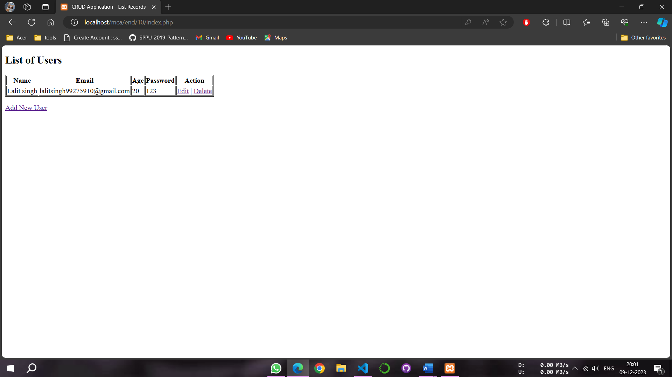

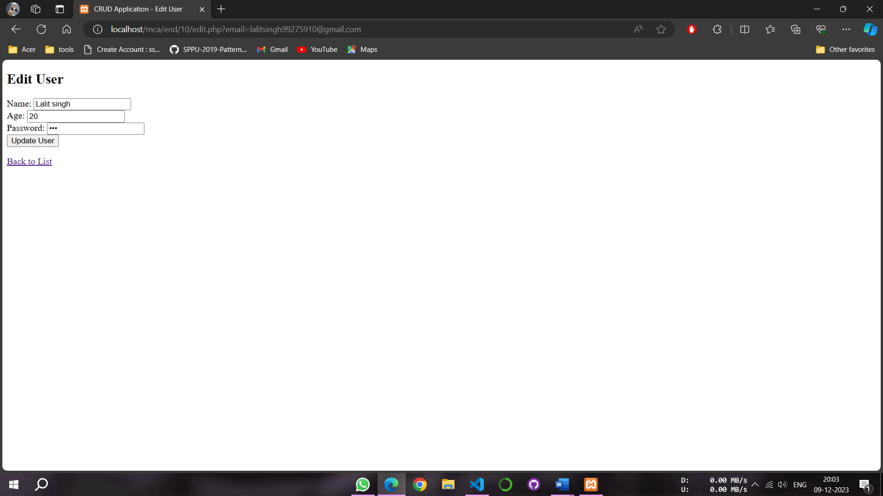

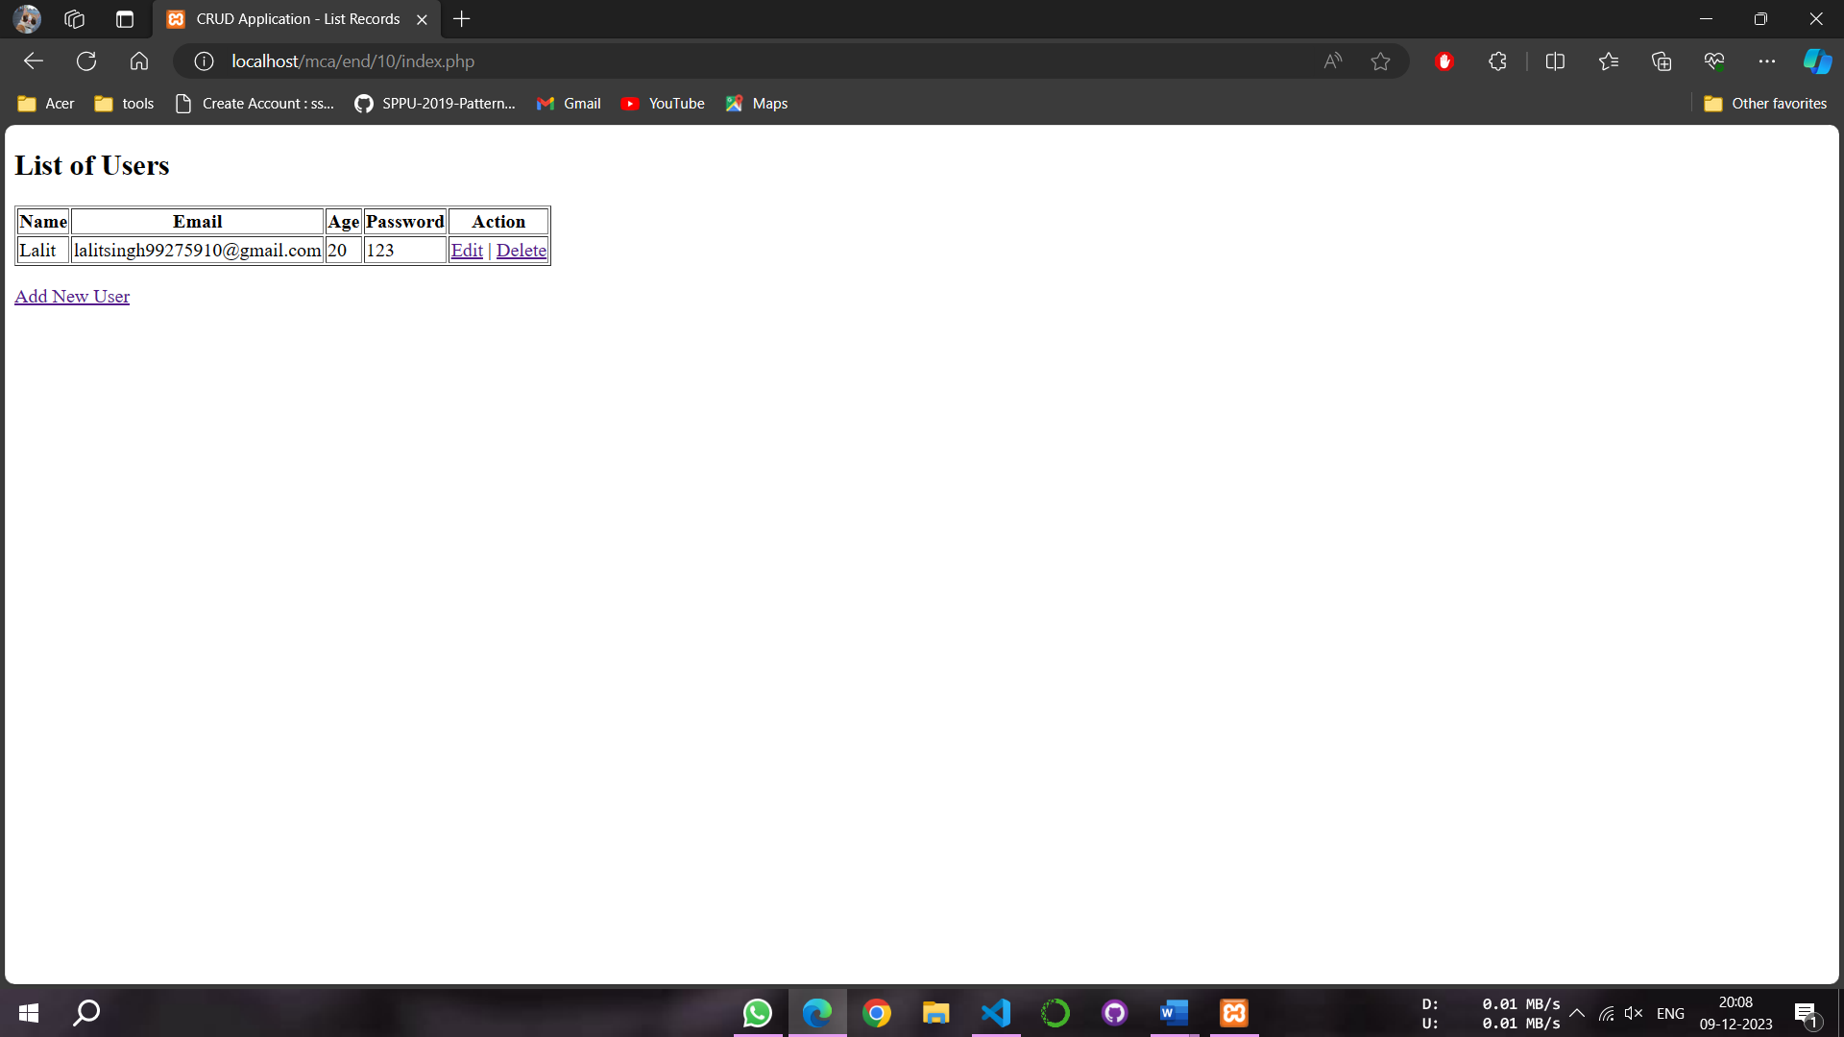

**PROGRAM 21**

NAME -Lalit singh

COURSE -MCA 1st Sem

ROLL NO -2351027

SUBJECT -Full Stack Development Laboratory (PMC-101)

**OBJECTIVE: To design a calculator with the help of HTML and JavaScript**

**Index.html**

<!DOCTYPE html>

<html lang="en">

<head>

<meta charset="UTF-8">

<meta name="viewport" content="width=device-width, initial-scale=1.0">

<title>Simple Calculator</title>

<style>

body {

font-family: Arial, sans-serif;

background-color: #f4f4f4;

display: flex;

justify-content: center;

align-items: center;

height: 100vh;

margin: 0;

}

#calculator {

background-color: #fff;

border: 1px solid #ccc;

border-radius: 8px;

padding: 20px;

width: 250px;

box-shadow: 0 0 10px rgba(0, 0, 0, 0.1);

}

input[type="text"] {

width: 100%;

padding: 10px;

margin-bottom: 10px;

box-sizing: border-box;

font-size: 1.5em;

}

input[type="button"] {

width: 48px;

height: 48px;

font-size: 1.2em;

margin: 5px;

cursor: pointer;

}

#result {

font-size: 1.5em;

margin-top: 10px;

padding: 15px 0 0 10px;

height: 40px;

border: 1px solid #ccc;

}

</style>

</head>

<body>

<div id="calculator">

<h3>Calculator</h3>

<input type="text" id="display" readonly>

<div id="result"></div>

<br>

<input type="button" value="7" onclick="appendToDisplay('7')">

<input type="button" value="8" onclick="appendToDisplay('8')">

<input type="button" value="9" onclick="appendToDisplay('9')">

<input type="button" value="/" onclick="appendToDisplay('/')">

<br>

<input type="button" value="4" onclick="appendToDisplay('4')">

<input type="button" value="5" onclick="appendToDisplay('5')">

<input type="button" value="6" onclick="appendToDisplay('6')">

<input type="button" value="*" onclick="appendToDisplay('*')">

<br>

<input type="button" value="1" onclick="appendToDisplay('1')">

<input type="button" value="2" onclick="appendToDisplay('2')">

<input type="button" value="3" onclick="appendToDisplay('3')">

<input type="button" value="-" onclick="appendToDisplay('-')">

<br>

<input type="button" value="0" onclick="appendToDisplay('0')">

<input type="button" value="." onclick="appendToDisplay('.')">

<input type="button" value="=" onclick="calculate()">

<input type="button" value="+" onclick="appendToDisplay('+')">

<br>

<input type="button" value="C" onclick="clearDisplay()">

</div>

<script>

function appendToDisplay(value) {

document.getElementById("display").value += value;

}

function clearDisplay() {

document.getElementById("display").value = "";

document.getElementById("result").innerText = "";

}

function calculate() {

try {

const result = eval(document.getElementById("display").value);

document.getElementById("result").innerText = result;

} catch (error) {

document.getElementById("result").innerText = "Error";

}

}

</script>

</body>

</html>

**OUTPUT:**

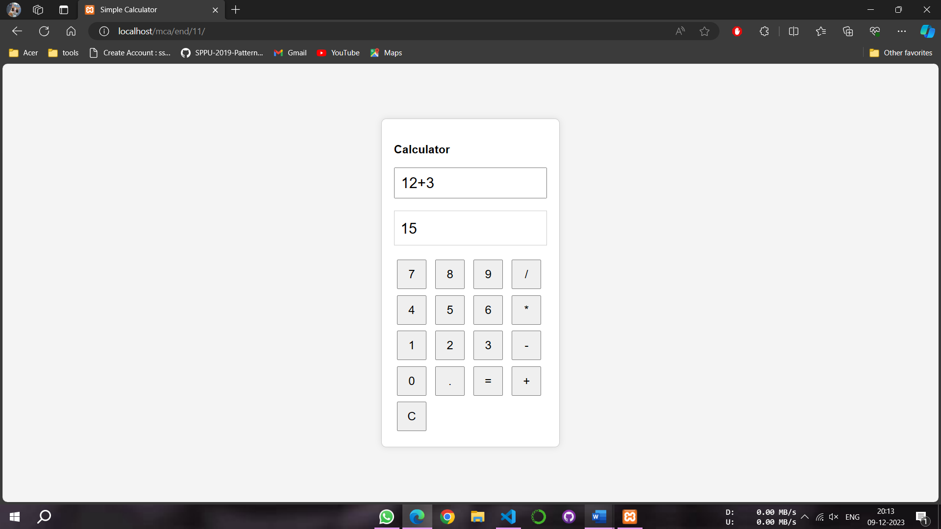

**PROGRAM 22**

NAME -Lalit singh

COURSE -MCA 1st Sem

ROLL NO -2351027

SUBJECT -Full Stack Development Laboratory (PMC-101)

**OBJECTIVE: To Design a web page with the help of three textboxes to add two numbers and display their sum in third textbox using JavaScript.**

**HTML CODE:**

<!DOCTYPE html>

<html lang="en">

<head>

<meta charset="UTF-8">

<meta name="viewport" content="width=device-width, initial-scale=1.0">

<title>Addition Calculator</title>

<style>

body {

font-family: Arial, sans-serif;

background-color: #f4f4f4;

display: flex;

justify-content: center;

align-items: center;

height: 100vh;

margin: 0;

}

#calculator {

background-color: #fff;

border: 1px solid #ccc;

border-radius: 8px;

width: 50vw;

padding: 20px;

box-shadow: 0 0 10px rgba(0, 0, 0, 0.1);

}

input[type="text"] {

width: 100%;

padding: 10px;

margin-bottom: 10px;

box-sizing: border-box;

font-size: 1.5em;

}

input[type="button"] {

width: 100%;

height: 48px;

font-size: 1.2em;

margin: 5px;

cursor: pointer;

}

</style>

</head>

<body>

<div id="calculator">

<h3>Sum of Two Number</h3>

<input type="text" id="num1" placeholder="Enter number 1">

<input type="text" id="num2" placeholder="Enter number 2">

<input type="text" id="result" readonly>

<input type="button" value="Add" onclick="addNumbers()">

</div>

<script>

function addNumbers() {

var num1 = parseFloat(document.getElementById("num1").value);

var num2 = parseFloat(document.getElementById("num2").value);

if (!isNaN(num1) && !isNaN(num2)) {

var sum = num1 + num2;

document.getElementById("result").value = sum;

} else {

document.getElementById("result").value = "Invalid input";

}

}

</script>

</body>

</html>

**OUTPUT**

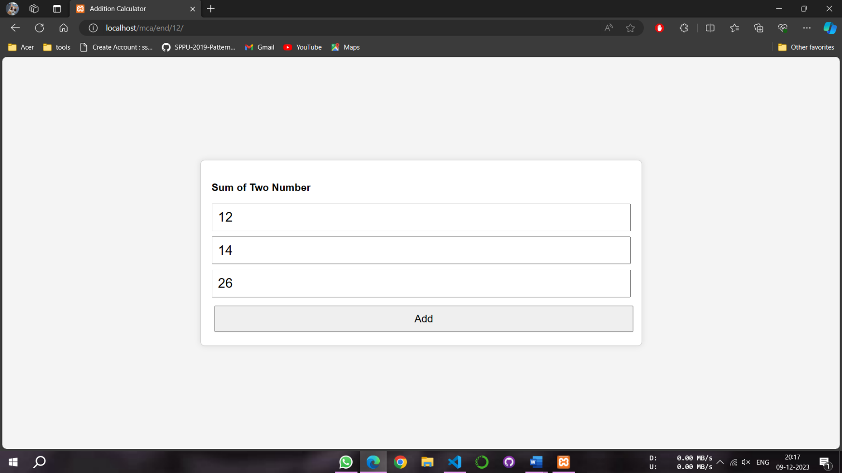

**PROGRAM 23**

NAME -Lalit singh

COURSE -MCA 1st Sem

ROLL NO -2351027

SUBJECT -Full Stack Development Laboratory (PMC-101)

**OBJECTIVE: To Write a program in PHP to demonstrate the use of GET, POST and REQUEST variable.**

**PhP CODE:**

1. **Index.php**

<!DOCTYPE html>

<html lang="en">

<head>

<meta charset="UTF-8">

<meta name="viewport" content="width=device-width, initial-scale=1.0">

<title>PHP Form Demo</title>

</head>

<body>

<h2>PHP Form Demo</h2>

<form action="process.php" method="post">

<label for="name">Name:</label>

<input type="text" id="name" name="name">

<br>

<br>

<label for="email">Email:</label>

<input type="email" id="email" name="email">

<br>

<br>

<input type="submit" value="Submit with POST">

</form>

<br><br>

<form action="process.php" method="get">

<label for="name">Name:</label>

<input type="text" id="name" name="name">

<br>

<br>

<label for="email">Email:</label>

<input type="email" id="email" name="email">

<br>

<br>

<input type="submit" value="Submit with GET">

</form>

</body>

</html>

1. **Process.php**

<?php

if ($_SERVER["REQUEST_METHOD"] == "POST" || $_SERVER["REQUEST_METHOD"] == "GET") {

$name = $_REQUEST["name"];

$email = $_REQUEST["email"];

echo "<h1>Form Data Submitted:</h1>";

echo "<h2>Reading Data through REQUEST Variable</h2>";

echo "<p>Name: $name</p>";

echo "<p>Email: $email</p>";

echo "<br>";

}

if ($_SERVER["REQUEST_METHOD"] == "POST" ){

$name1 = $_POST["name"];

$email1 = $_POST["email"];

echo "<h2>Reading Data through POST Variable</h2>";

echo "<p>Name: $name</p>";

echo "<p>Email: $email</p>";

}

if ($_SERVER["REQUEST_METHOD"] == "GET" ){

$name1 = $_GET["name"];

$email1 = $_GET["email"];

echo "<h2> Reading Data through GET Variable</h2>";

echo "<p>Name: $name</p>";

echo "<p>Email: $email</p>";

}

?>

**OUTPUT:**

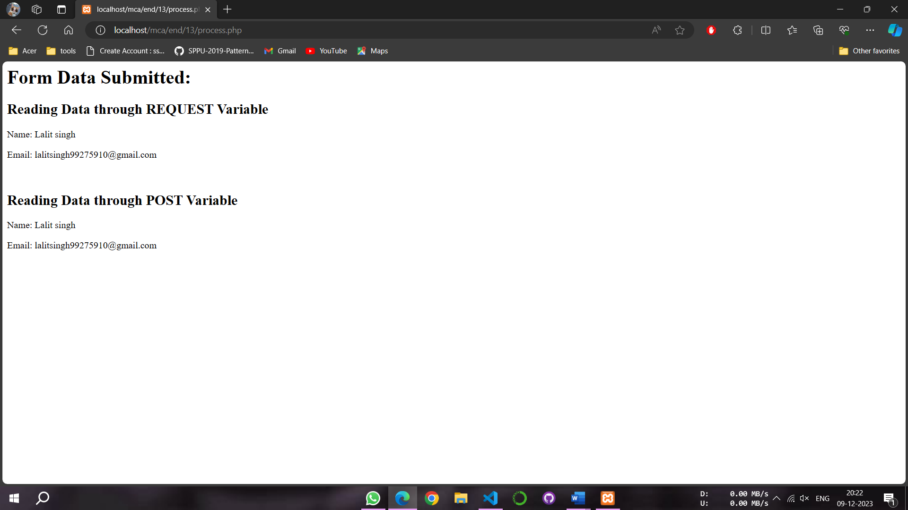

**PROGRAM 24**

NAME -Lalit singh

COURSE -MCA 1st Sem

ROLL NO -2351027

SUBJECT -Full Stack Development Laboratory (PMC-101)

**OBJECTIVE: To design a calculator with the help of HTML and JavaScript.**

**OUTPUT:**

<!DOCTYPE html>

<html lang="en">

<head>

<meta charset="UTF-8">

<meta name="viewport" content="width=device-width, initial-scale=1.0">

<title>Factorial Calculator</title>

</head>

<body>

<h2>Factorial Calculator</h2>

<form action="" method="post">

<label for="number">Enter a number:</label>

<input type="number" id="number" name="number" required>

<input type="submit" value="Calculate Factorial">

</form>

<?php

function calculateFactorial($n) {

if ($n == 0 || $n == 1) {

return 1;

} else {

return $n * calculateFactorial($n - 1);

}

}

if ($_SERVER["REQUEST_METHOD"] == "POST") {

$number = $_POST["number"];

if (is_numeric($number) && $number >= 0) {

$factorial = calculateFactorial($number);

echo "<p>Factorial of $number is: $factorial</p>";

} else {

echo "<p>Please enter a non-negative numeric value.</p>";

}

}

?>

</body>

</html>

**OUTPUT:**

